**PART 1 (FYI: the link to this video does not work. I had to do a Google search for this to watch it.)**

Suzanne Simard’s TED talk was very reminiscent to a childhood movie I watched many times, FernGully. In the movie, all of the elements in the rainforest had life and personality as the fairies attempted to save “her” (the forest) from loggers that decimated large areas, close to extinction. Simard pointed out that she had proof that trees are able to communicate to one another and that they understand family and future (Simard, 2016). It was all rather interesting to hear her speak on the experiments she has done and how she came to these ideas. I have always had a certain fondness for old trees, and now I can identify them as mother trees, the elders that pass on the great wisdom to their descendants. Much respect.

**Reference:**

Simard, S. (2016, Aug 30). *How trees talk to each other.* [Video file]. Retrieved from https://www.youtube.com/watch?v=Un2yBgIAxYs

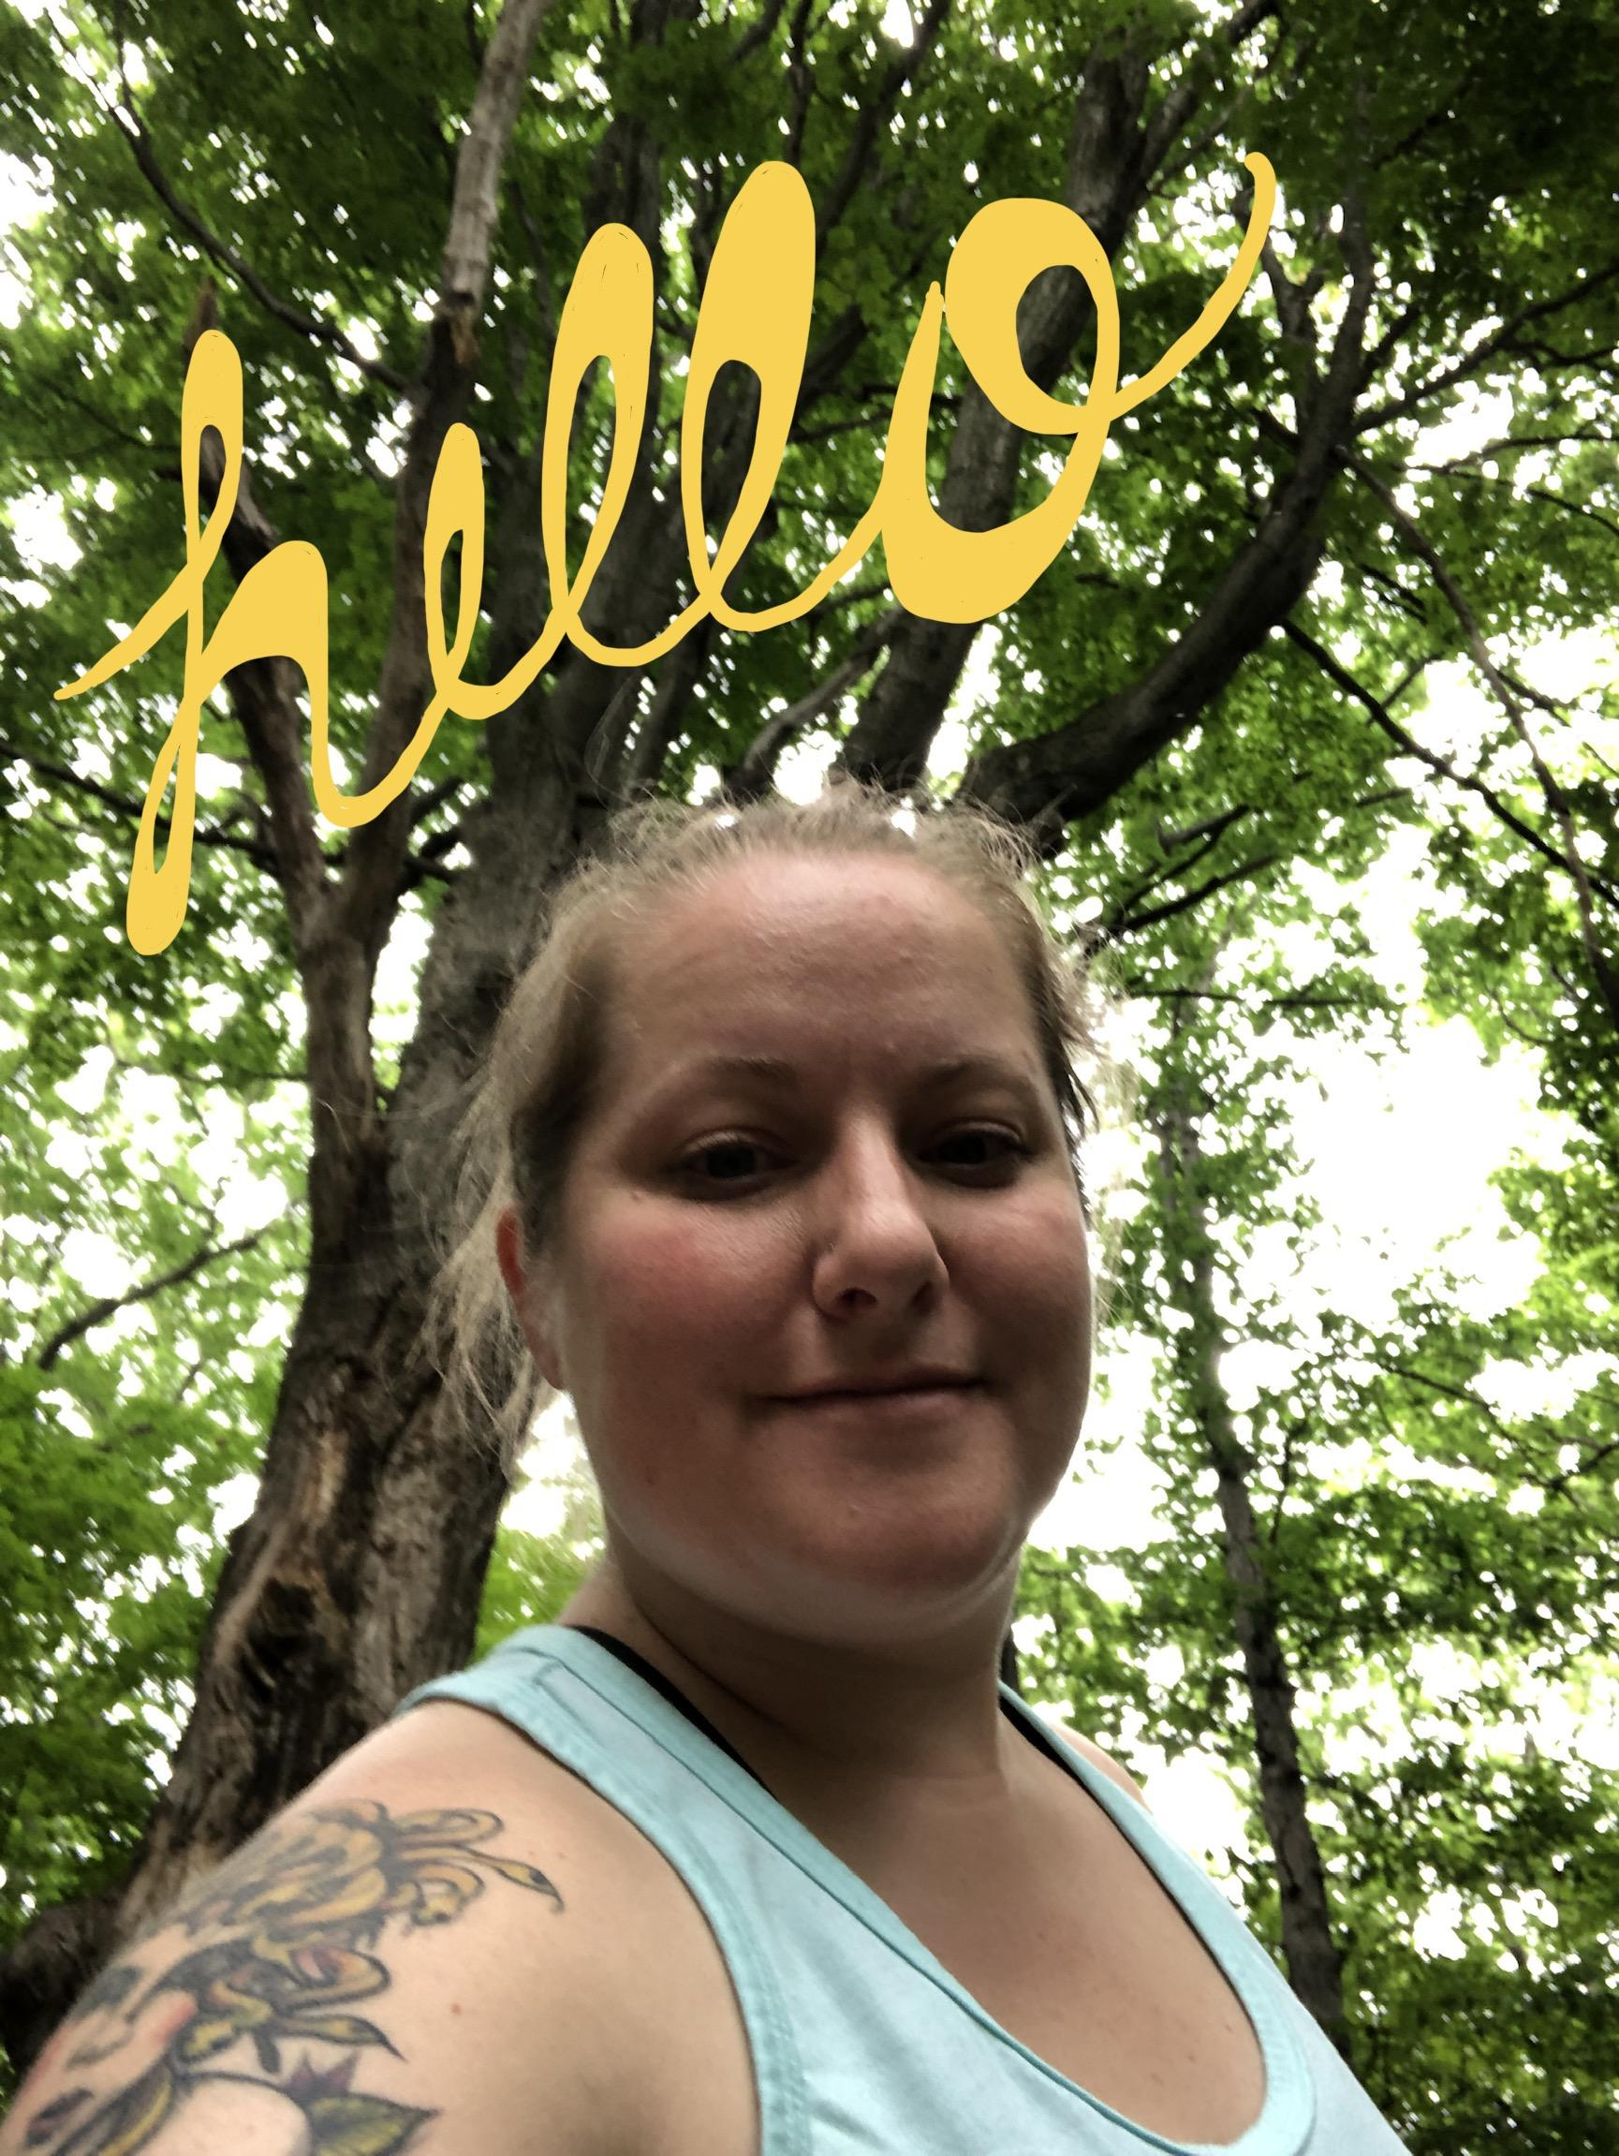

**PART 2 - Field exploration**

On June 17th, 2019 at approximately 5:30pm - 7:00pm, I visited the trails and pond area of Hawk Meadow Park on the westside of Lansing. It was mostly cloudy, approximately 68 degrees fahrenheit and mostly cloudy with a 74% humidity level.

Surprisingly, as I made my way through the woods, there were not many mosquitoes attempting to feast on my bare arms! Even more surprising because there were many areas with standing water [abiotic] from our many, many days of rain lately [water cycle]. I did stay on the paved trail for most of my walk even though there are unpaved trails throughout the park.

The rain has definitely benefited the trees and ground cover; they were lush and a very vibrant green color [photosynthesis/production of chlorophyll]. There was definitely poison ivy present all over. As I walked, I heard a myriad of birds speaking to each other, possibly to me, telling me about their day. I observed a deer having dinner [consumer] at the edge of a cut back corn field [producer], reminding me that I hadn’t eaten yet. 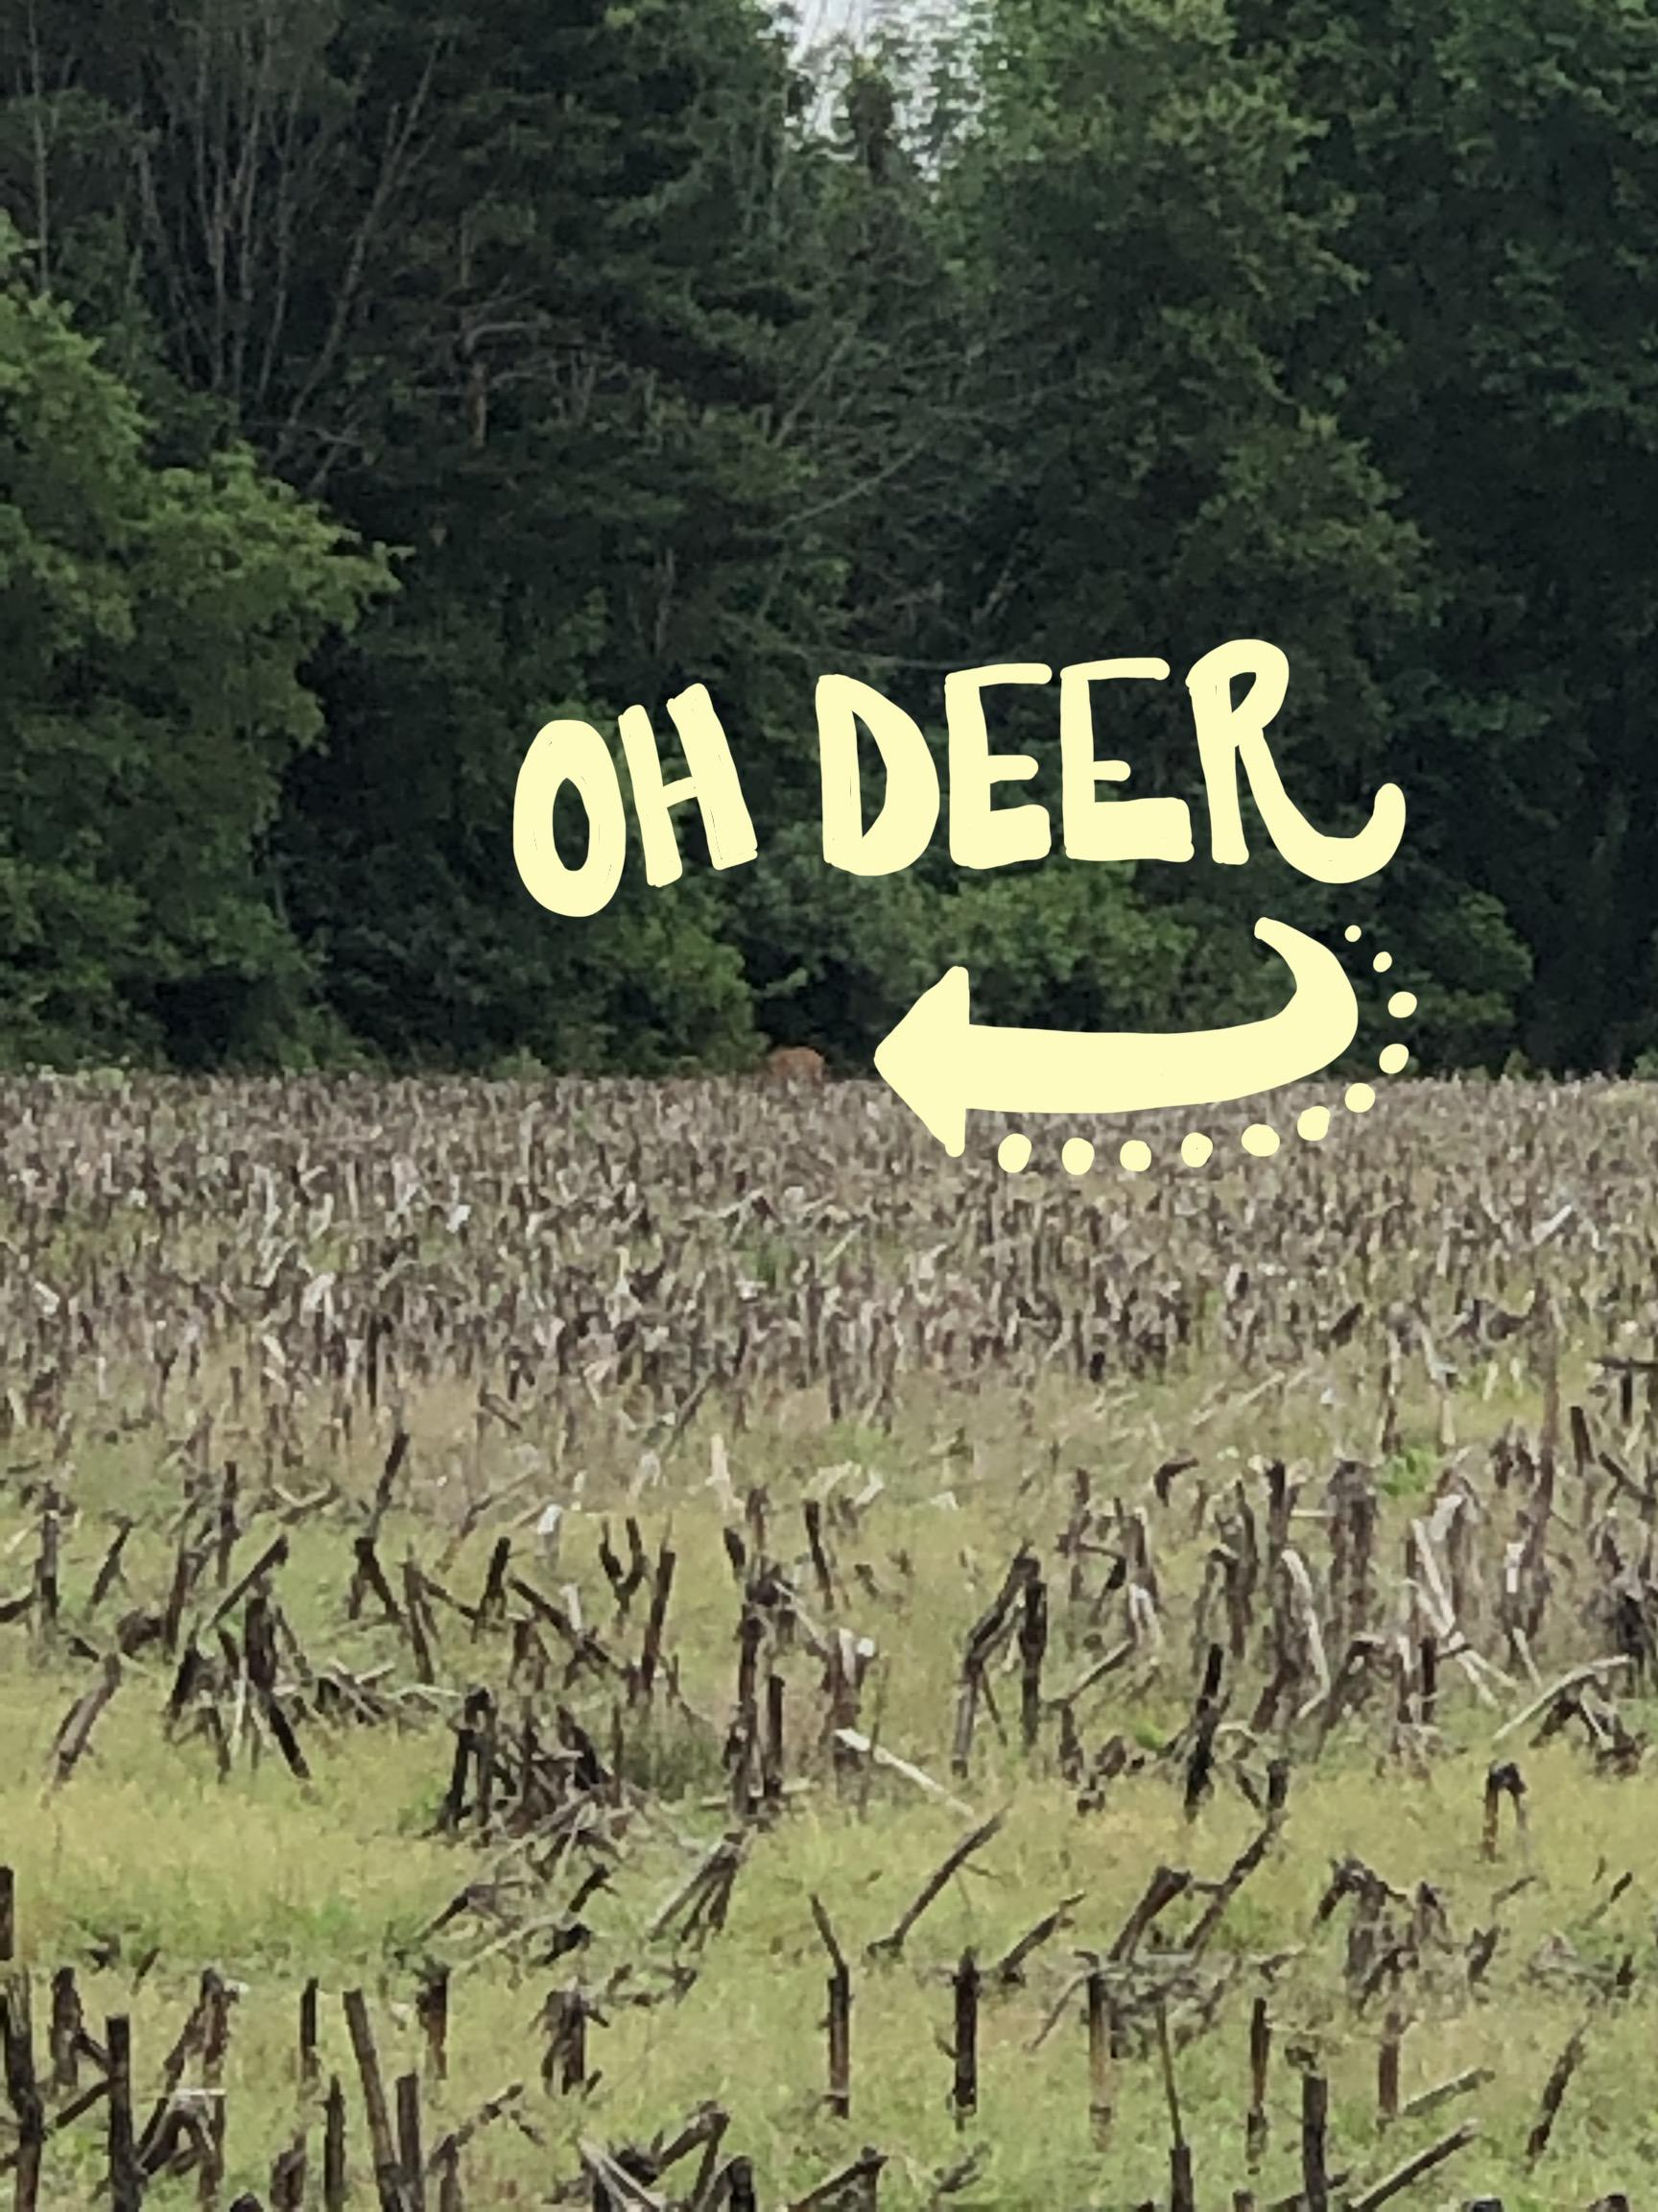

Upon finding the pond area [community], my ears were aware of many different species [biodiversity] surrounding me [ecosystem]: the frogs were chirping, the birds chattering and the trill of the tree frogs [keystone species - control bug population] repeated on each side of me. Further observation revealed ants diligently at work on the bridge rails and dragonflies resting upon rigid cattail stems poking through thick algae that sealed the surface of the water. Getting up close and personal, I was given chills by a cicada resting on a thick leaf breaching the bridge as well as the shell of a cicada nymph that had been outgrown - cool but super creepy looking!

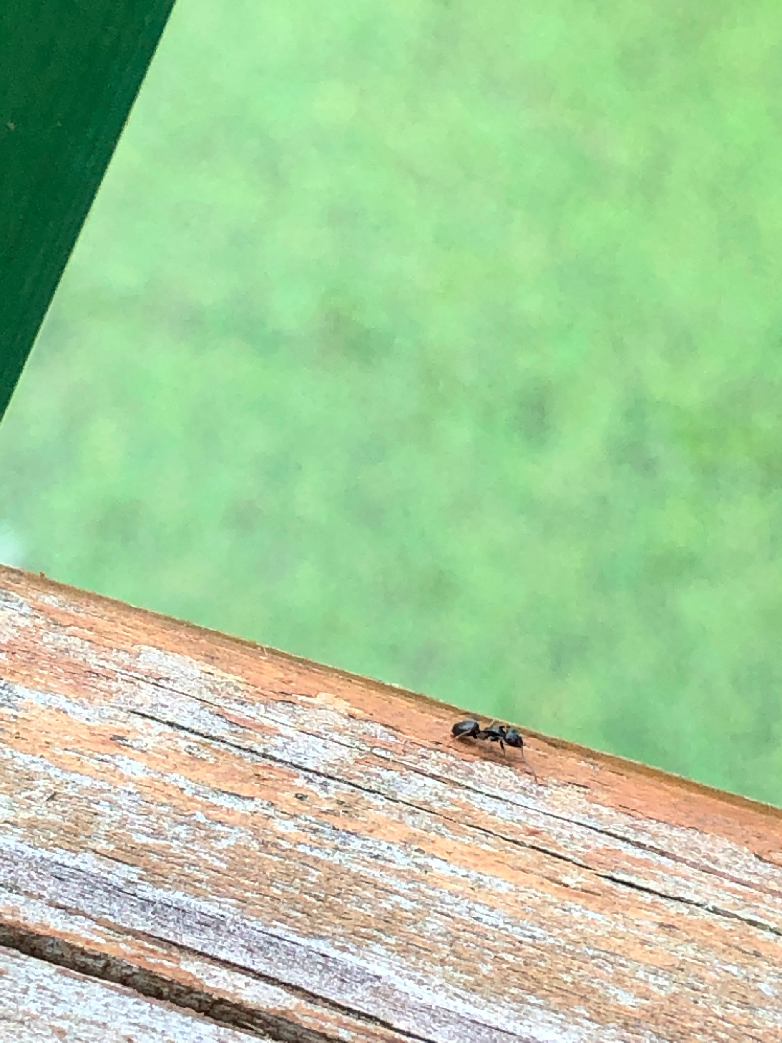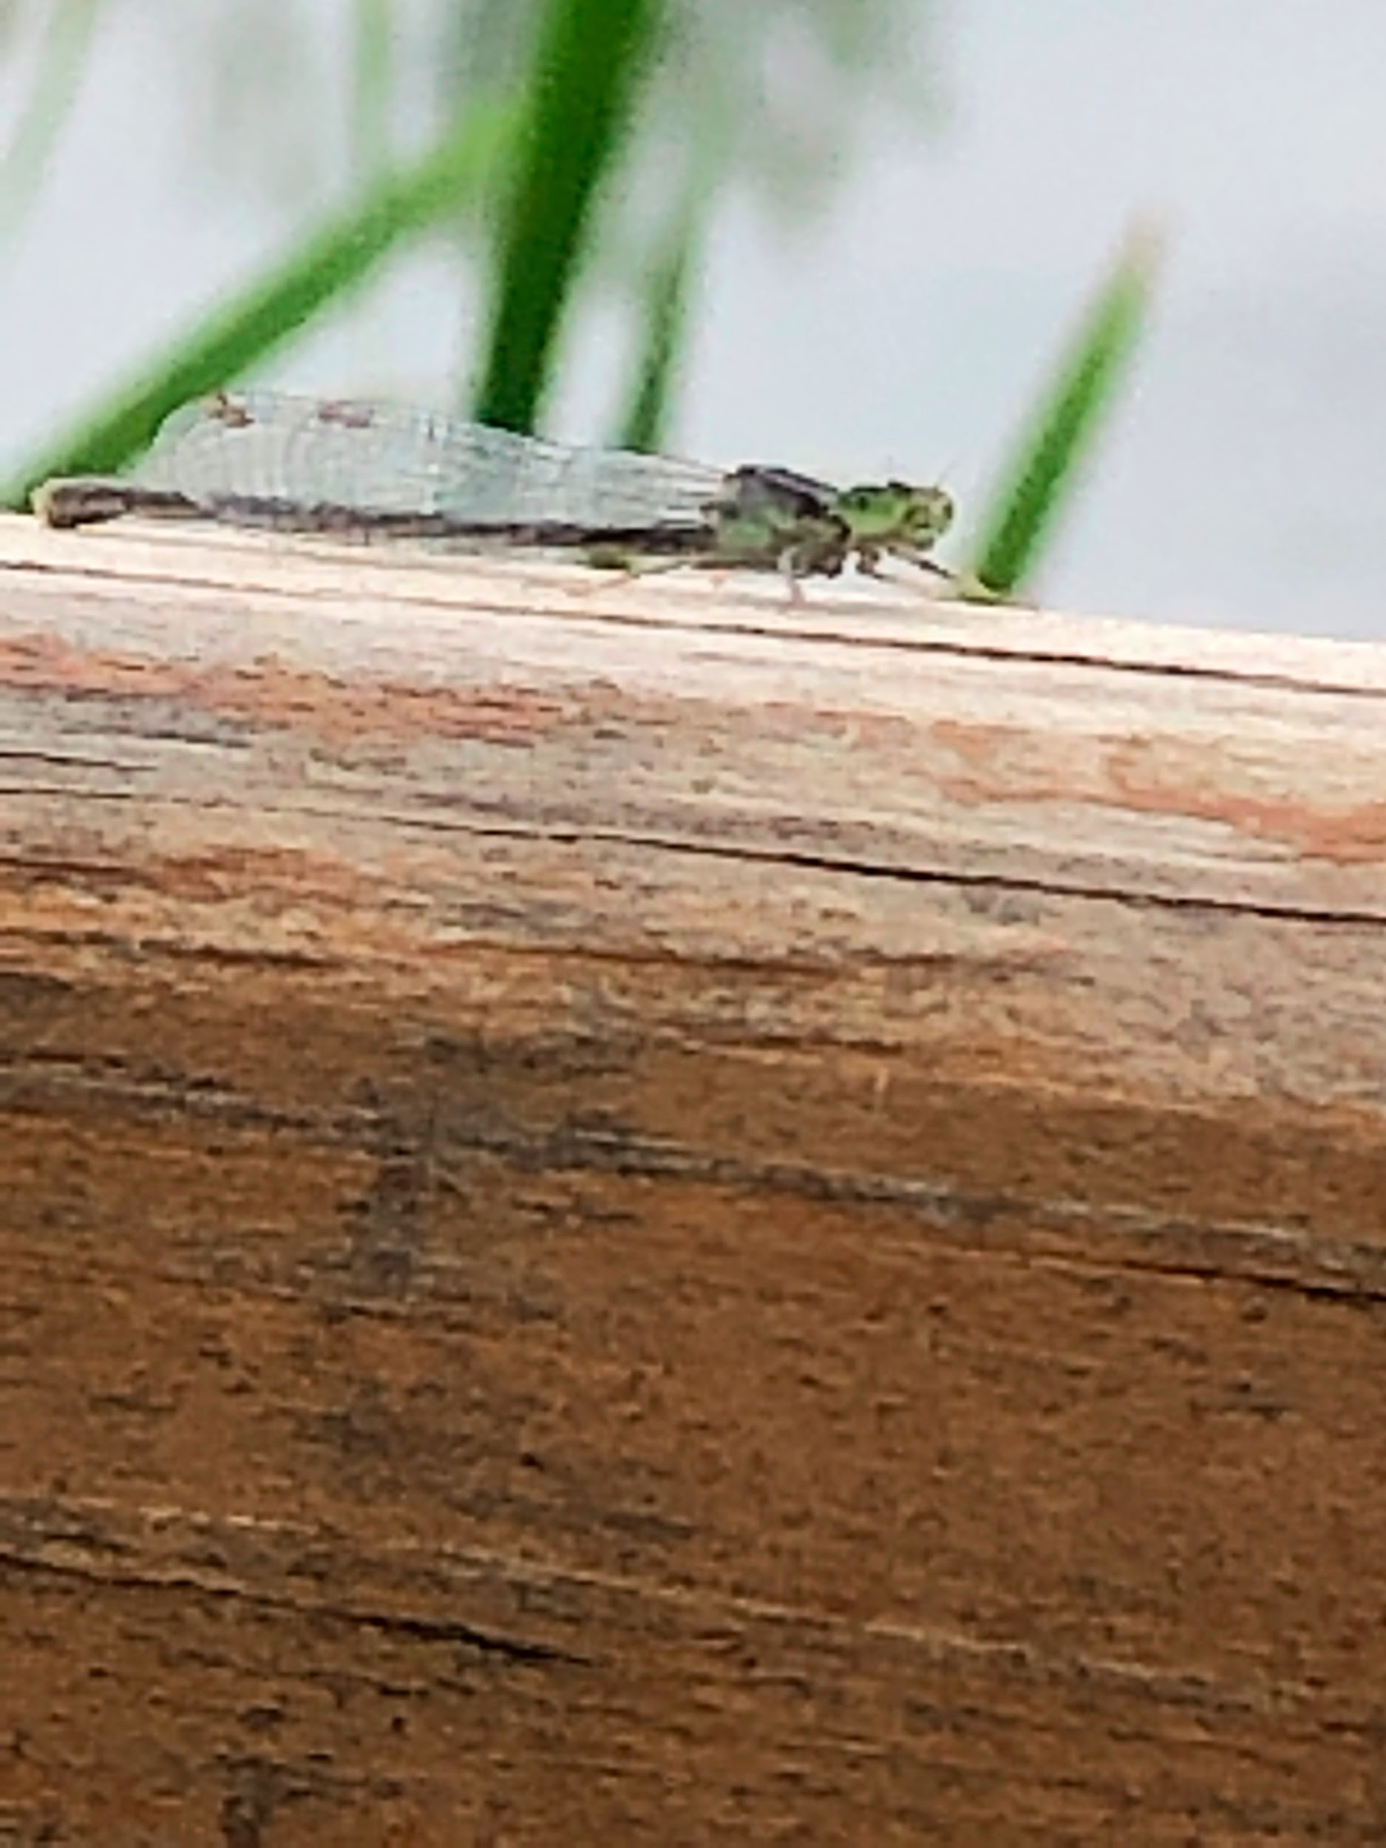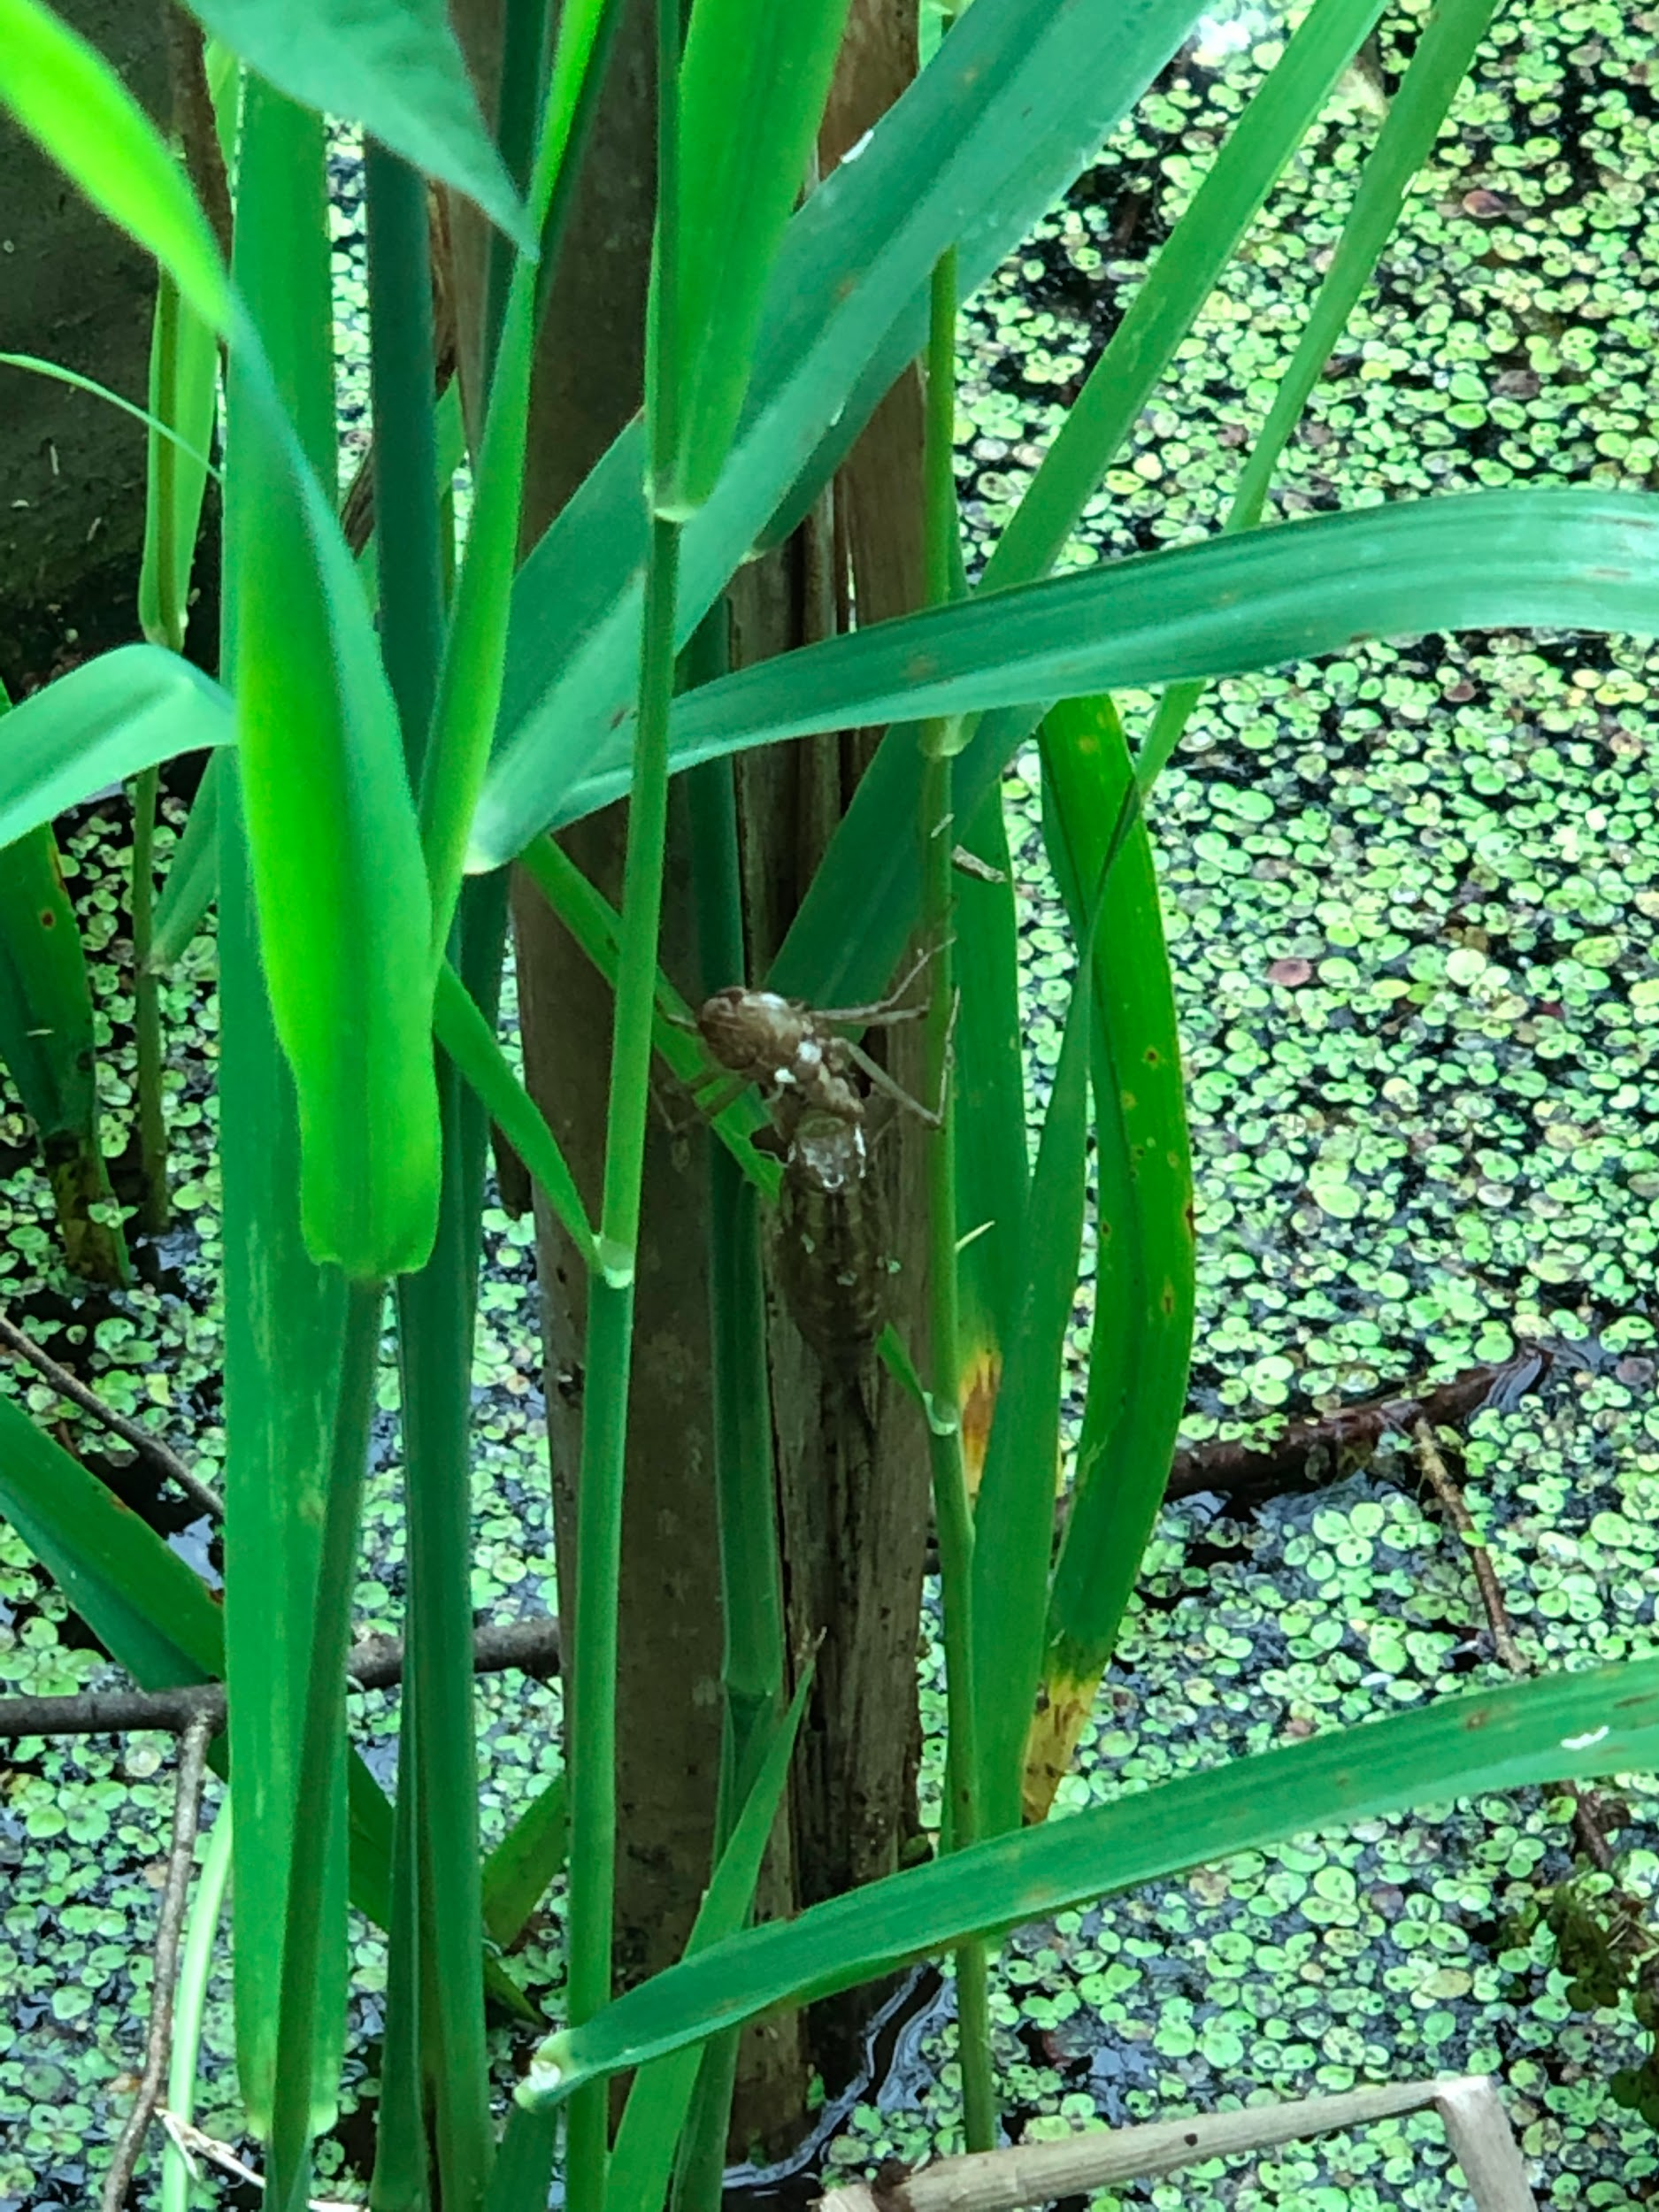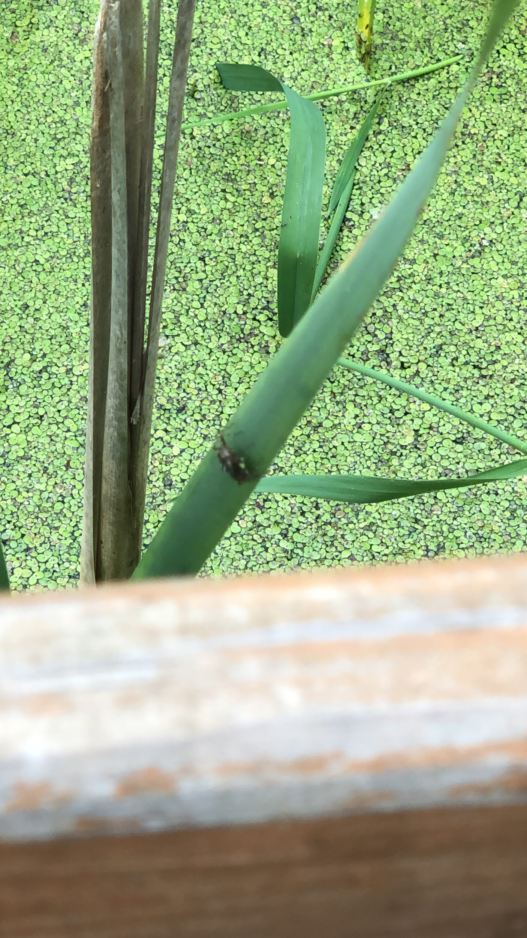

Much (visual and audible) hunting finally found me a tree frog. His cryptic coloring made it very difficult to visualize, as he sat still, watching my movement. It was only once he decided to speak to me, that I was able to see the ripple in the water from the vibrations of his speech.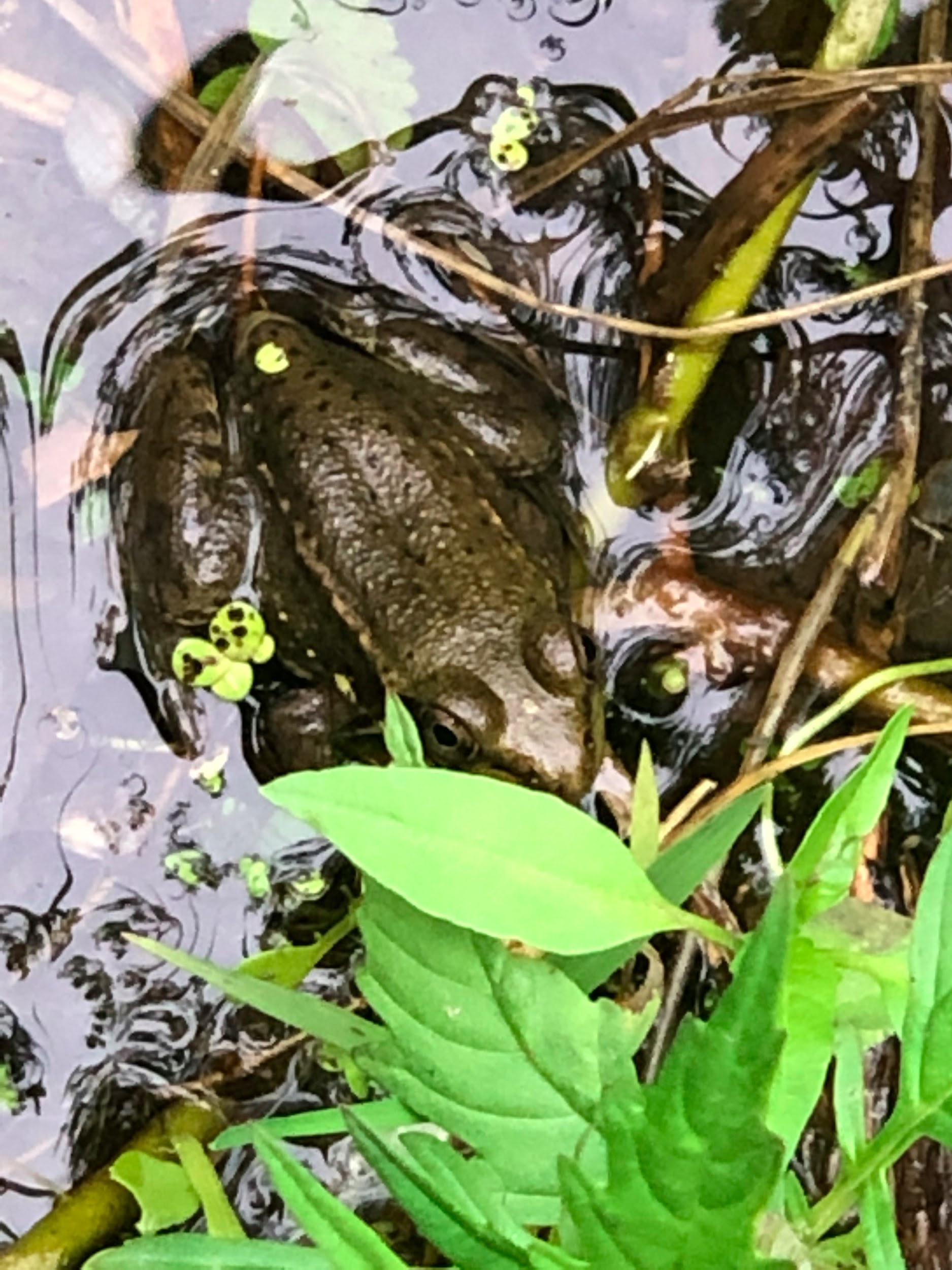

On my way back, I noticed a large fungus growing off of an equally large tree at the edge of the pond.

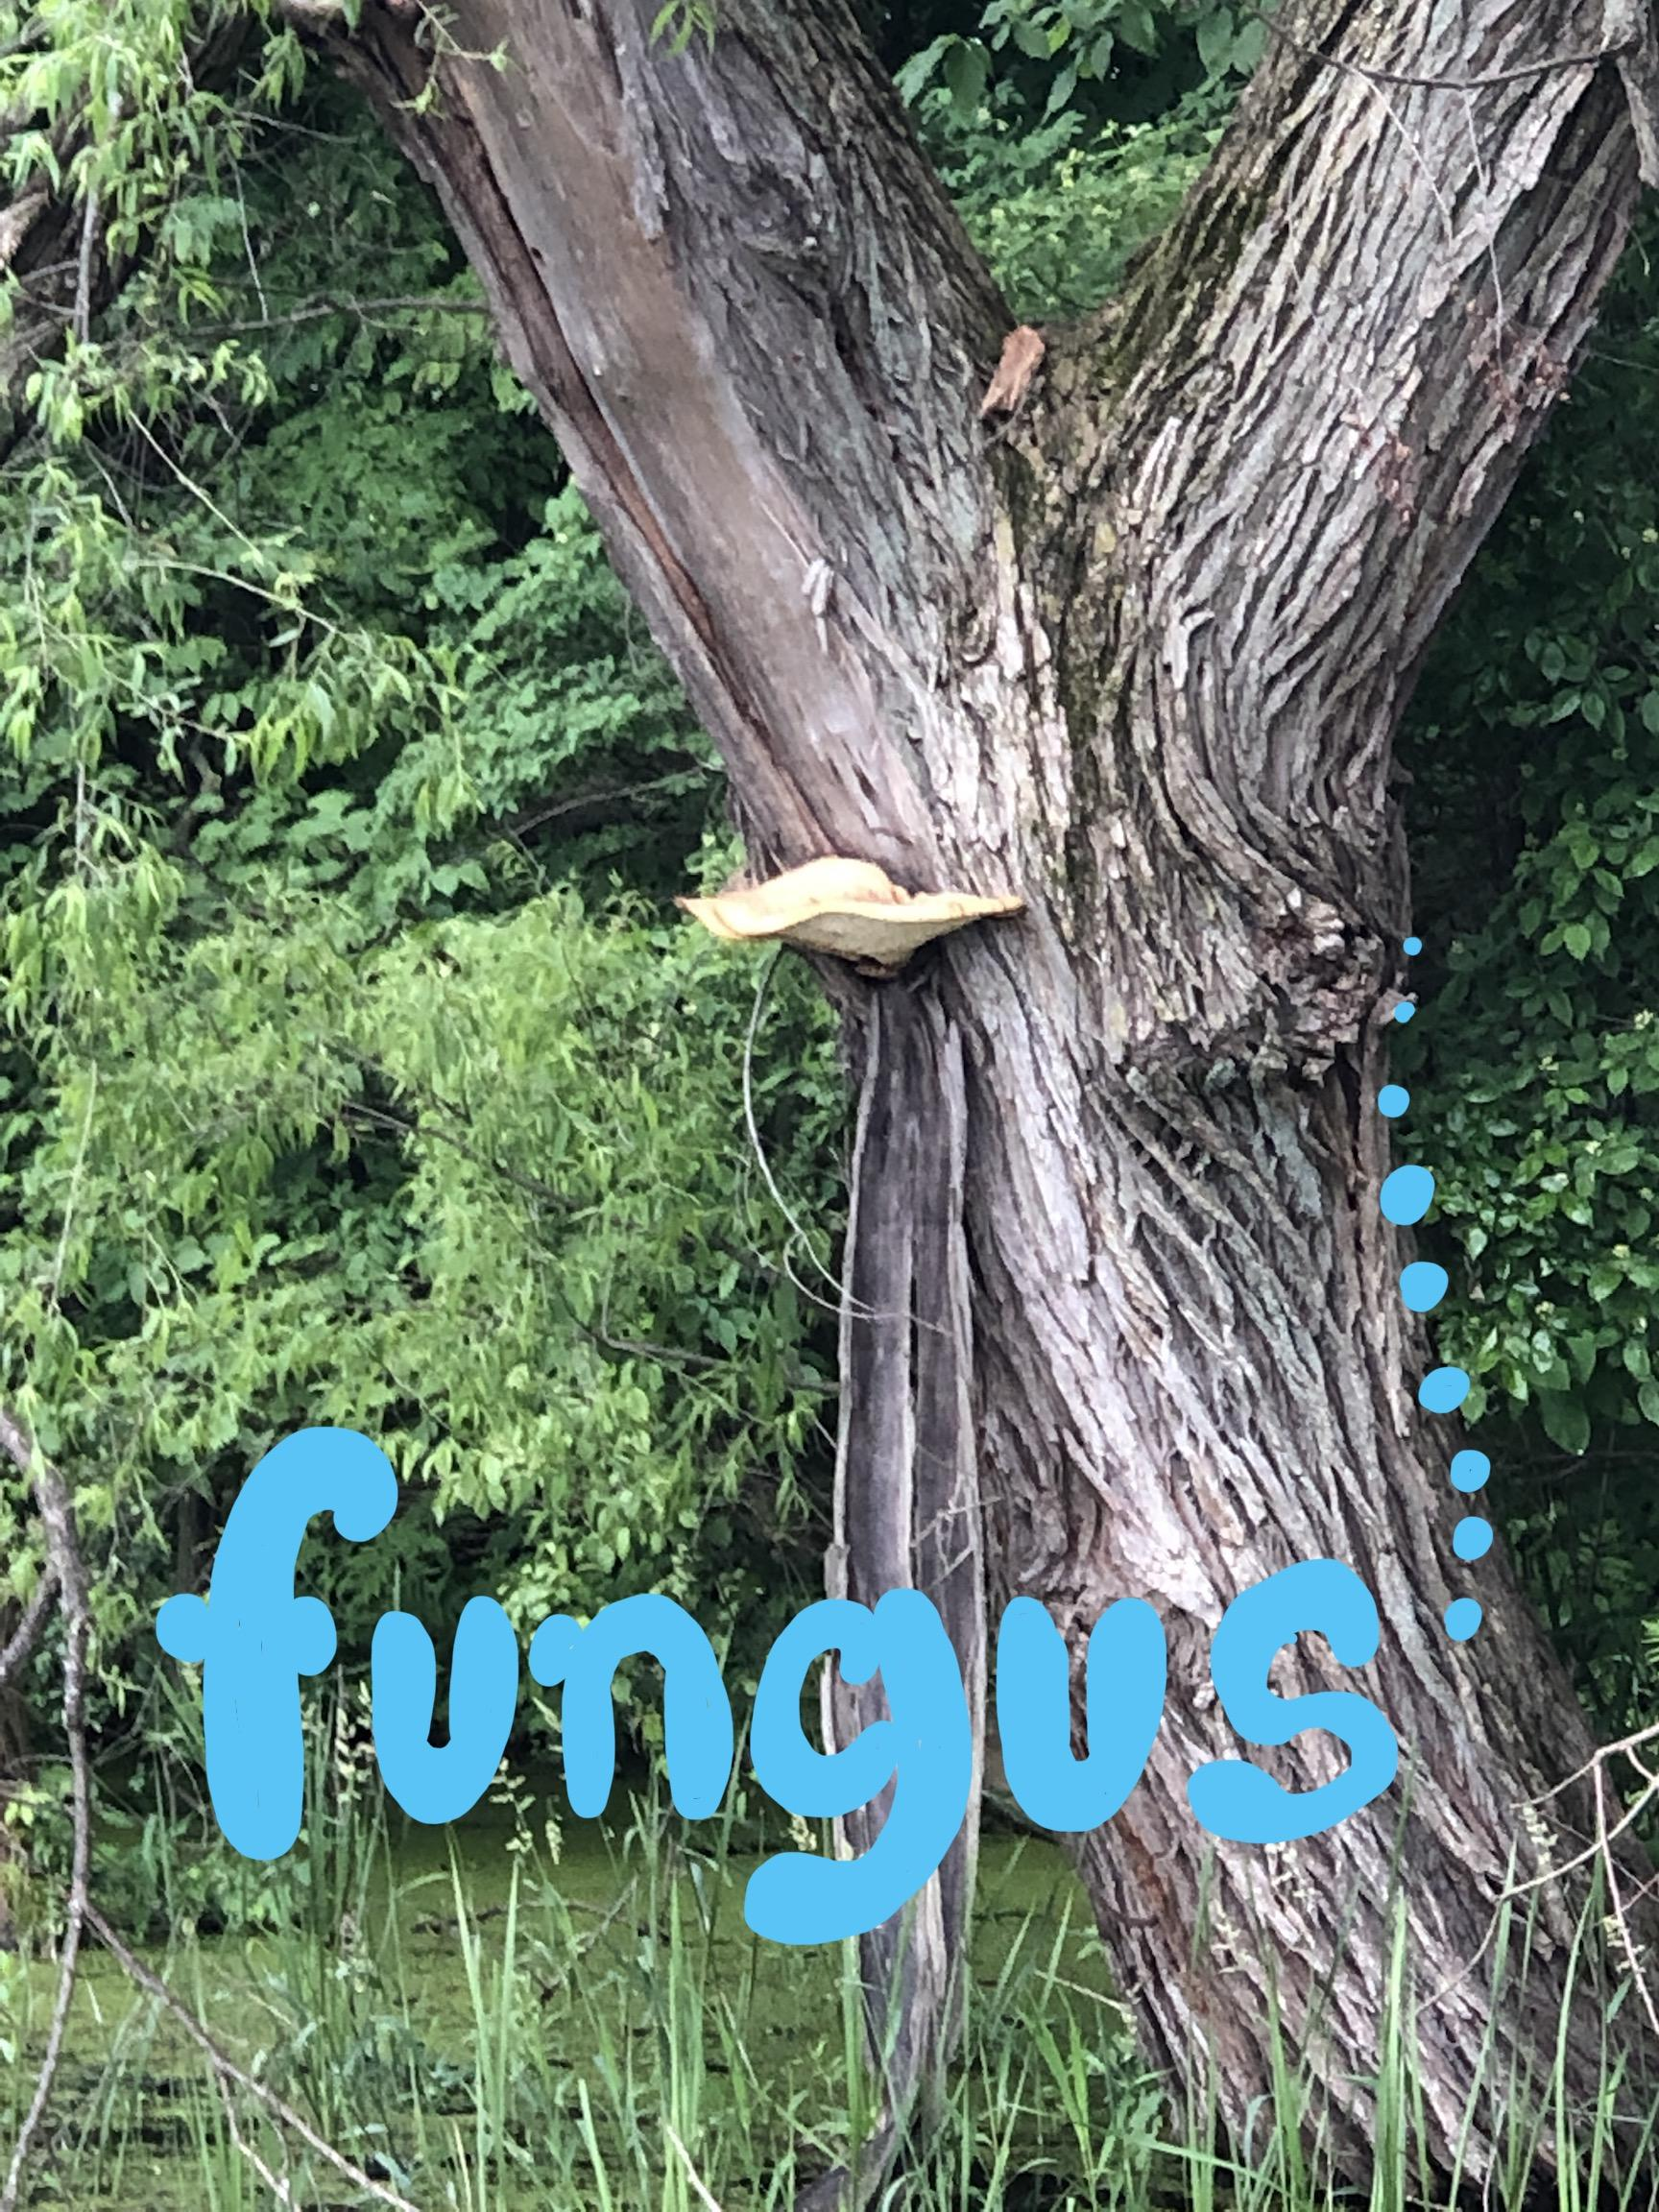

I also got brave enough to step off of the paved trail for a moment in a seemingly rather clear part of the woods to flip a decomposing tree branch. Upon flipping the wood, tons of tiny black dots began to flow like that of a wave. It took a moment to realize that they were black ants. I could tell from the sawdust-like debris on the ground that these little guys had been busy transforming that rotting wood [decomposers]!

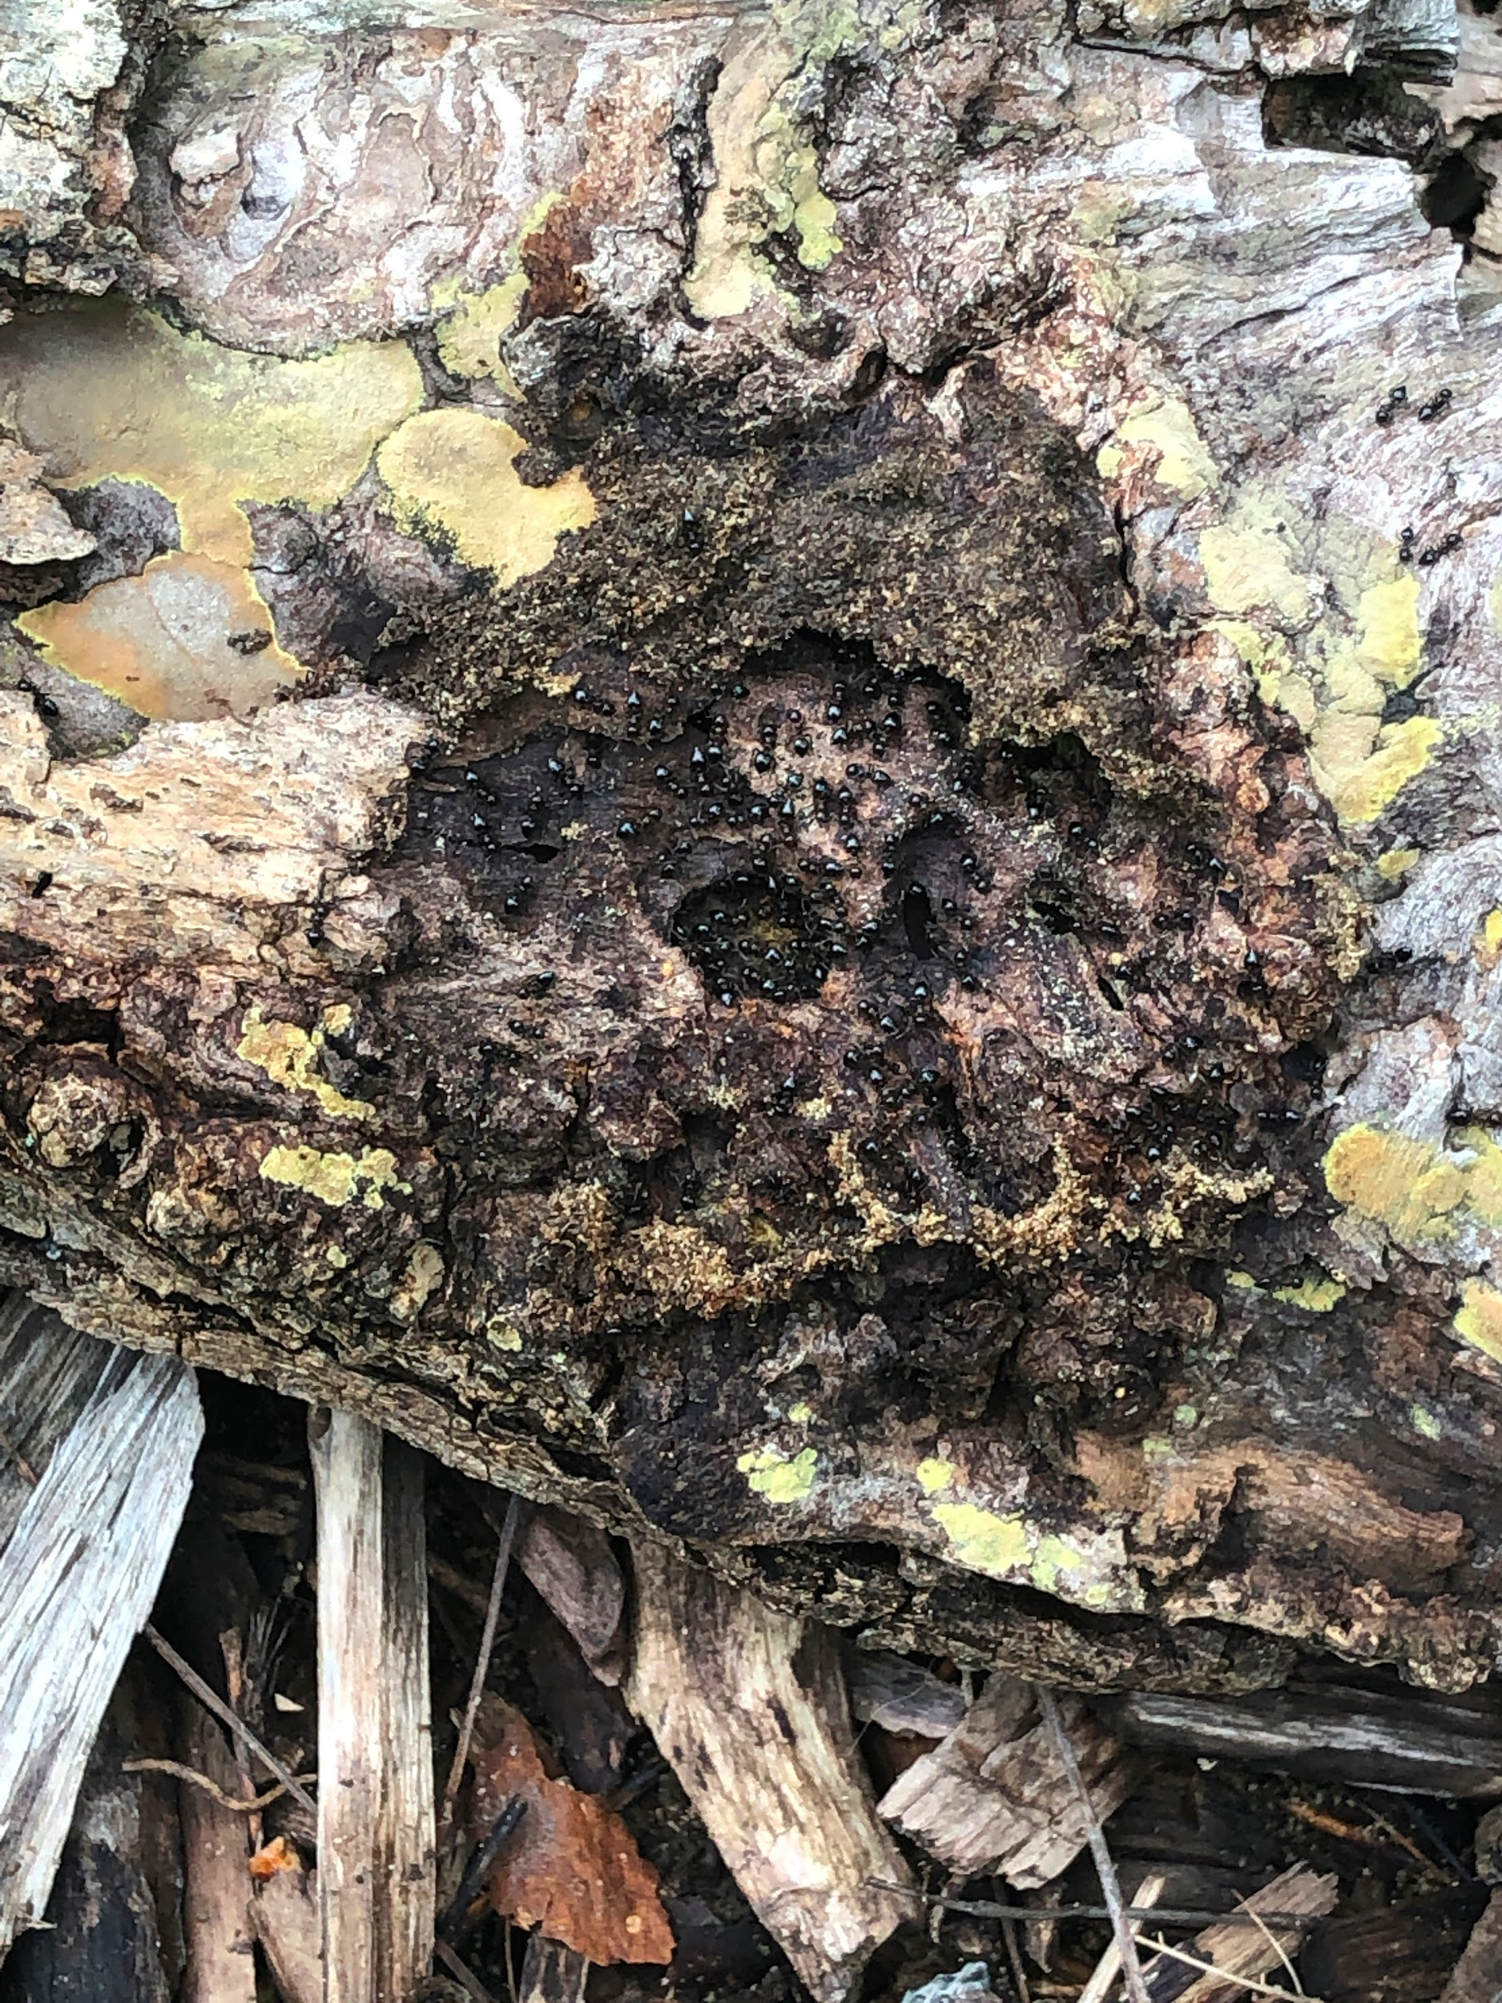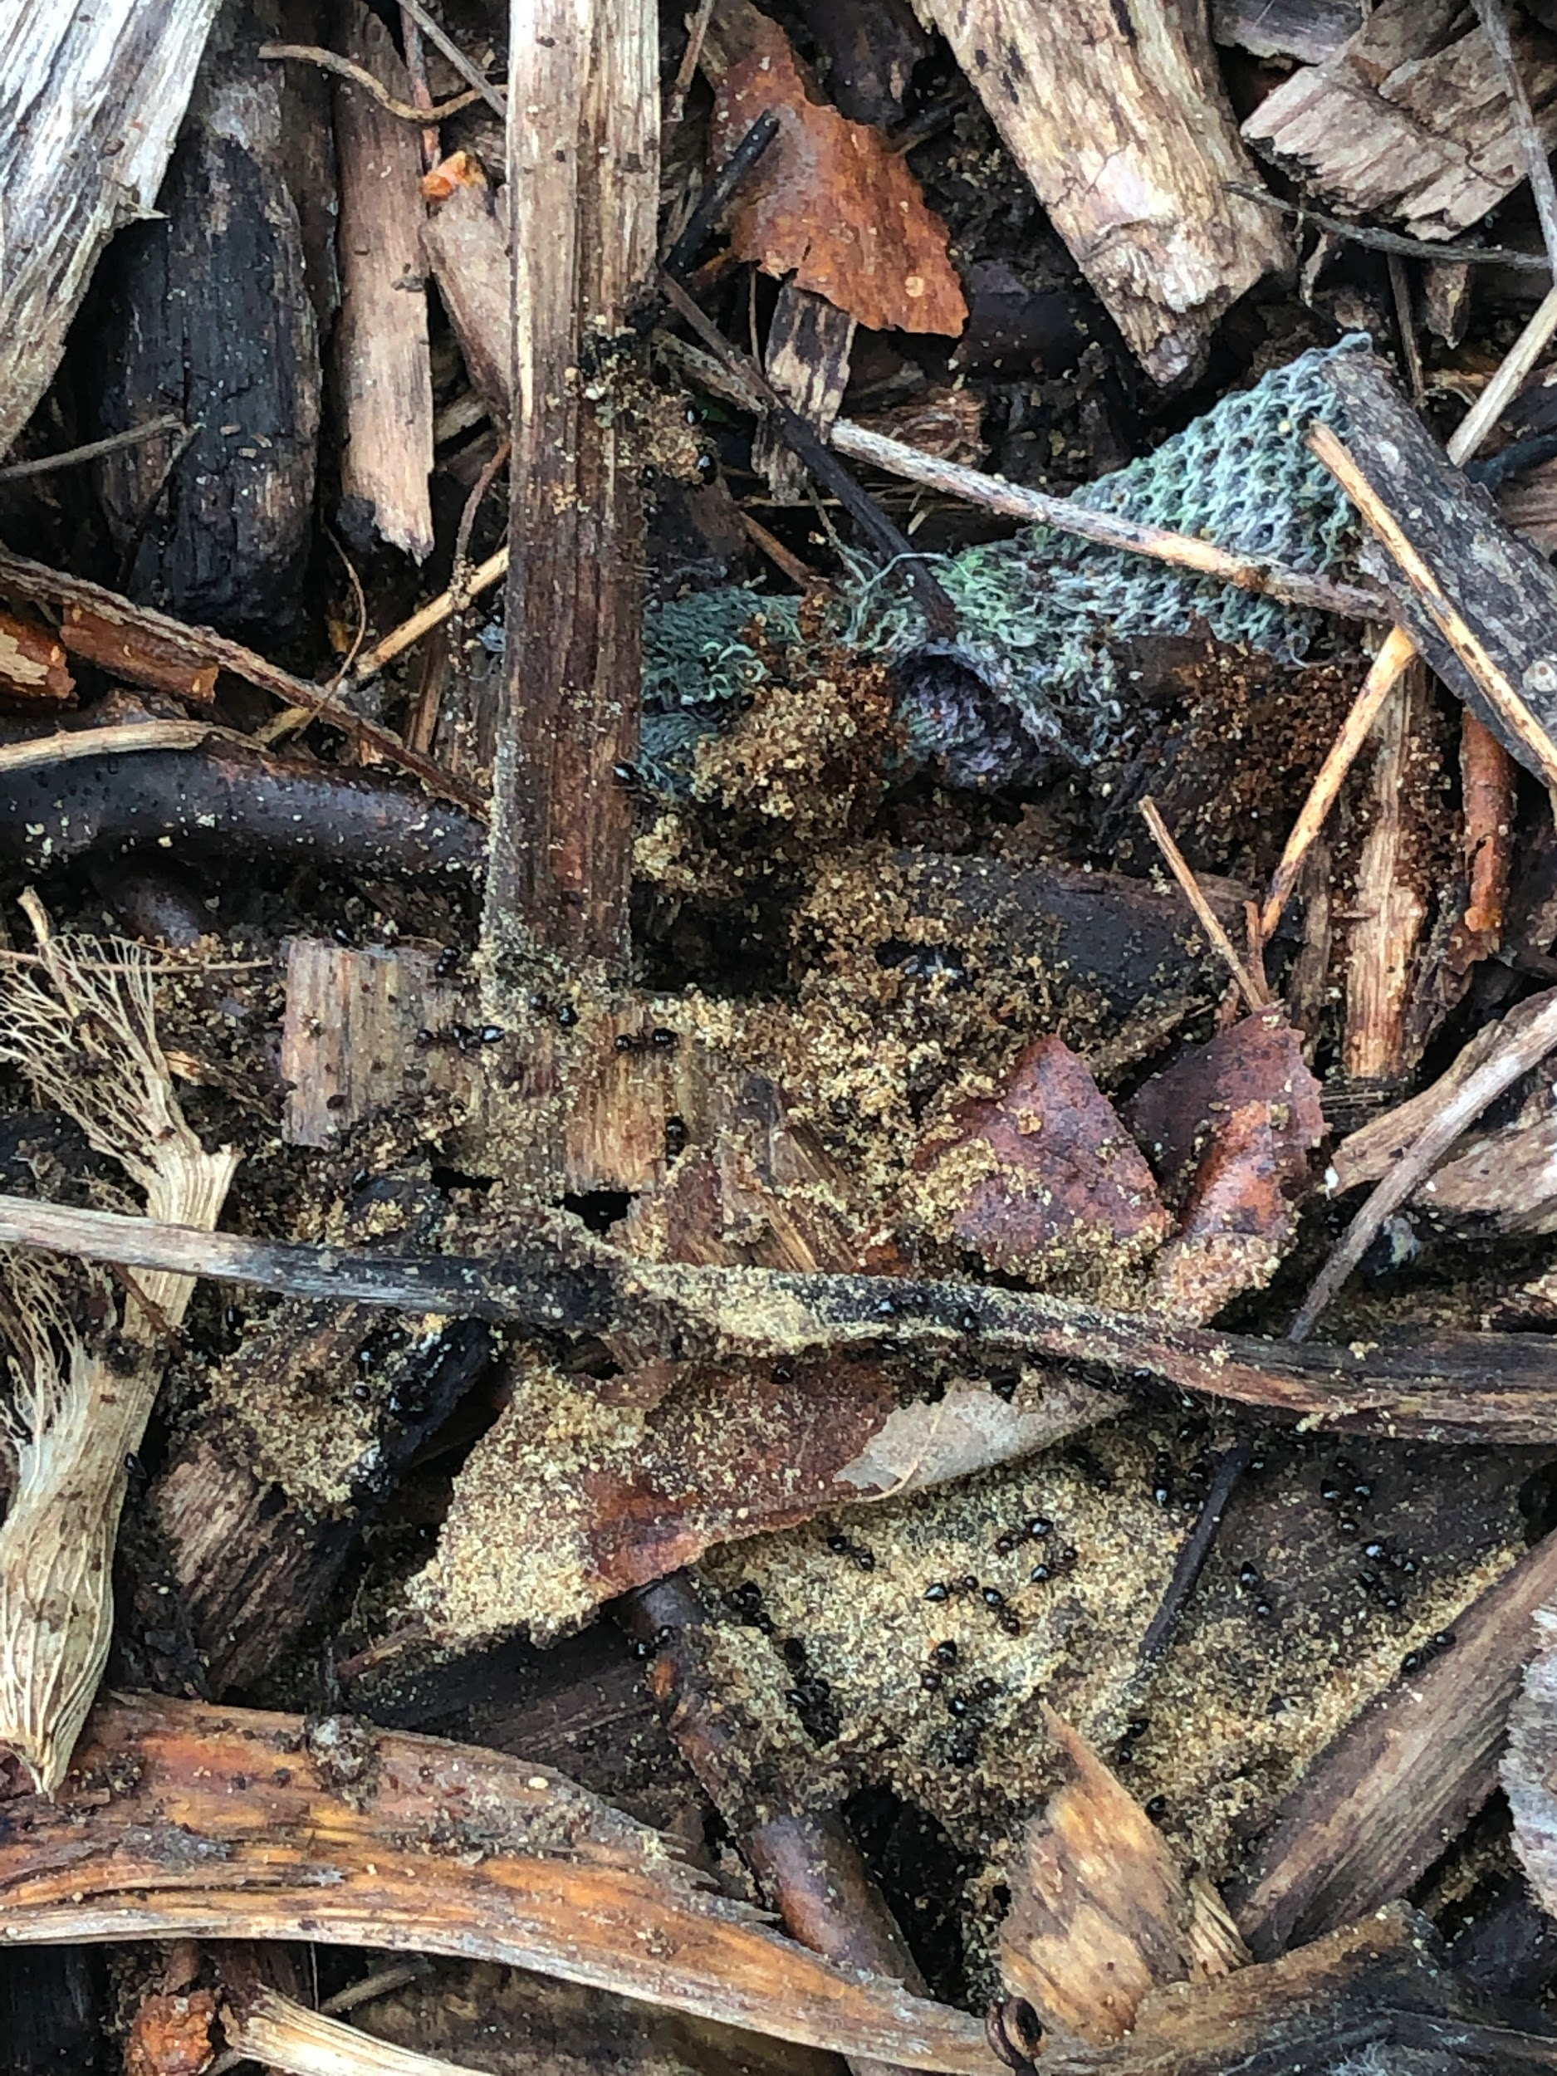

As far as what I consider to be the most important aspect that a Michigan forest/woodland brings to modern society, that is a very difficult thing to narrow down and I am not sure if there can be *one specific thing*. The trees produce fresh air for us (and the majority of other species) to breathe, but without water, sunlight and carbon dioxide from other species’ respiration, trees would cease to exist. Trees also cool the land in their immediate surrounding area, creating a milder habitat as well as a protected habitat within the tree itself or under the cover of thick leaves. In a way, humans have a symbiotic relationship with the nature that is and exists in and around trees.